How to create a Weebly…
- Go to the website: http://www.weebly.com/
- Fill in the Full Name, Email and Password information and click “Get Started.”
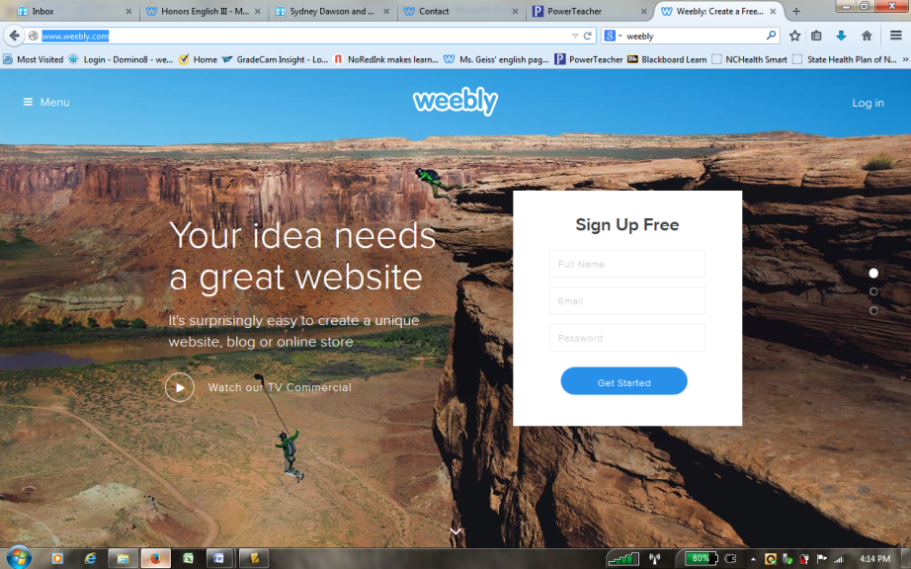

- Select the Focus as “Site.”
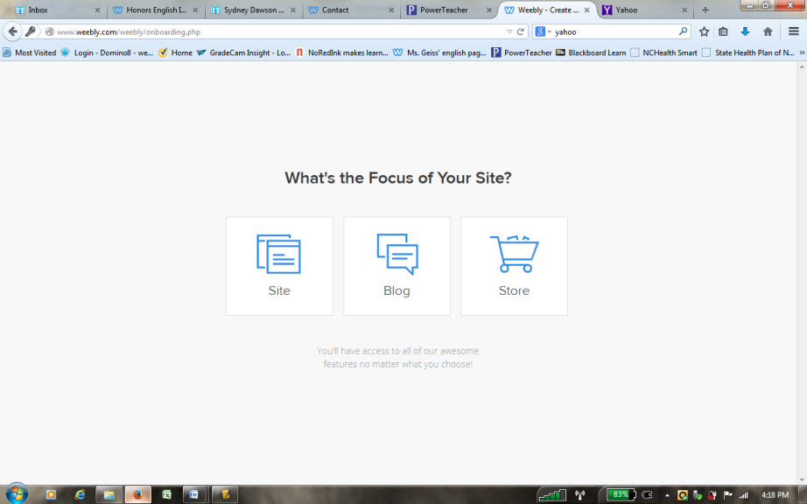

- Select your theme. The theme should have something do with your topic.
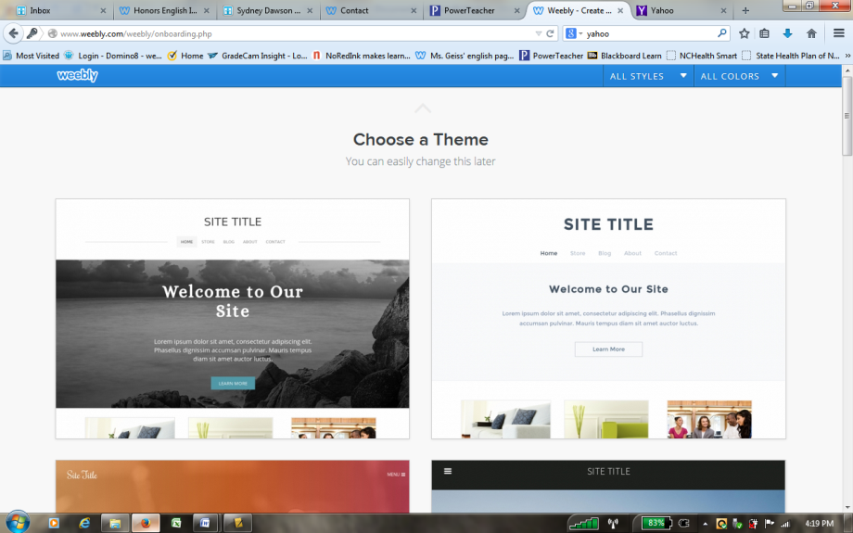
- Create a domain name. You MUST enter your information in the first box labeled “Use a Subdomain of Weebly.com” if you want a free website. Then click “Continue.”
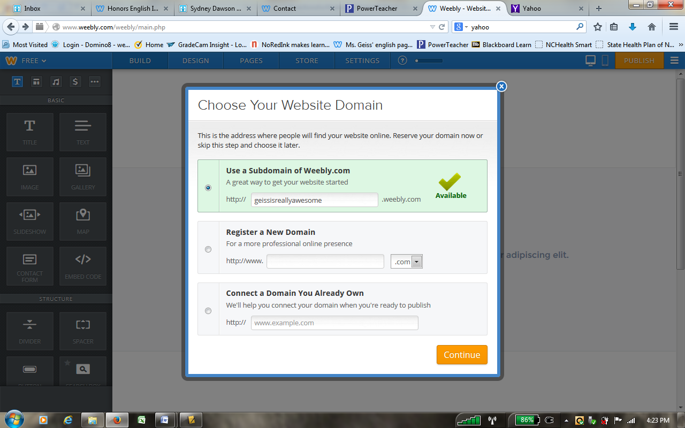
- You should then have your website. It should look something like this. Next you need to send the link to me. In order to do this, please click the orange “Publish” button in the top right corner.
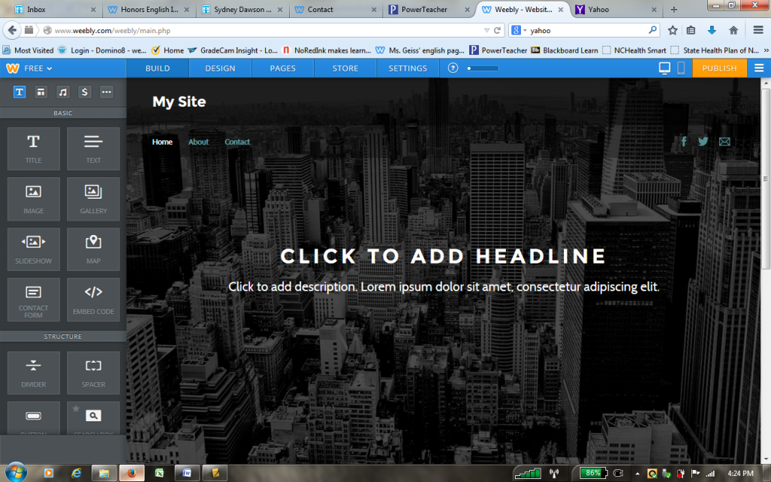
- Categorize your website for “Education” and “Class Project.” Then click “Continue.”
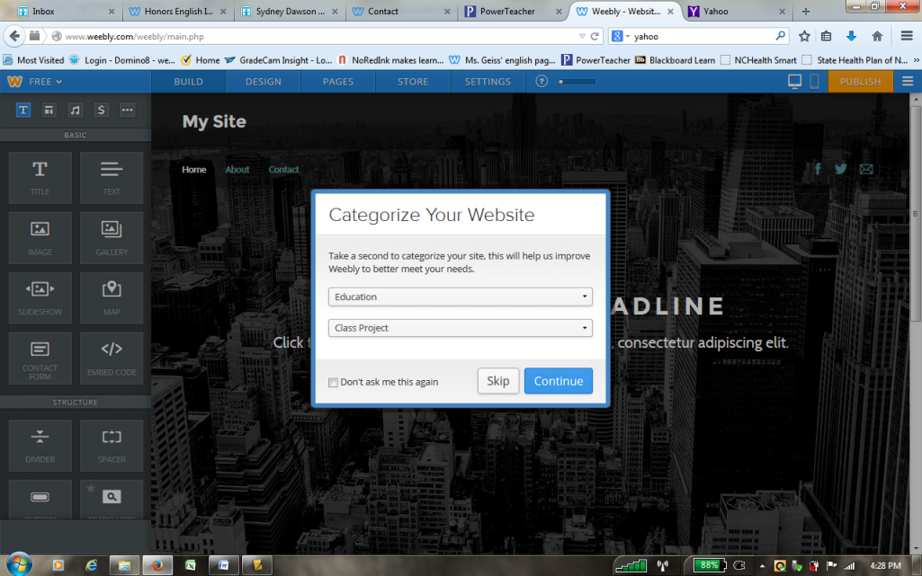
- Verify your website by typing in the code that appears on your personal screen.
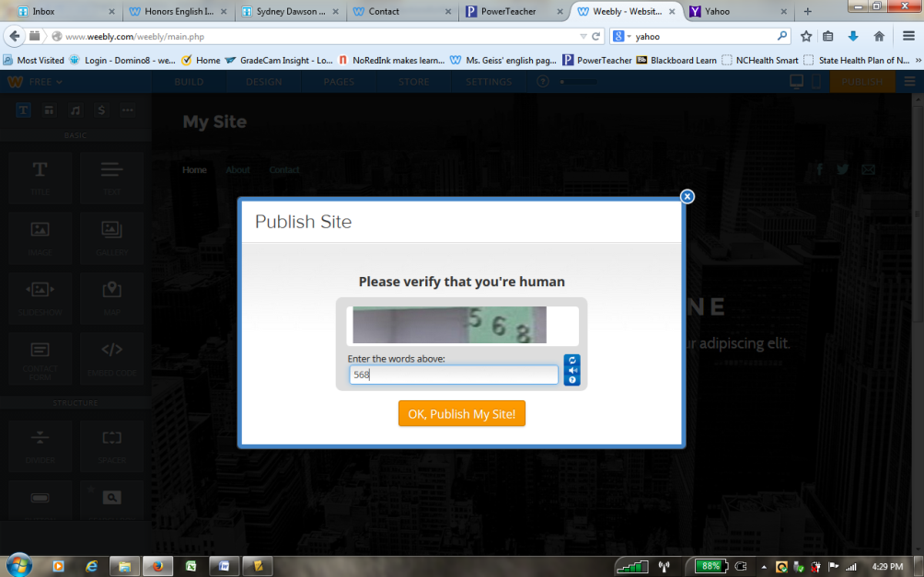

- A box saying that your website has been published will appear. Do NOT click continue; it will try to sell you something. Instead, click on the “X” located in the upper right corner of the box.
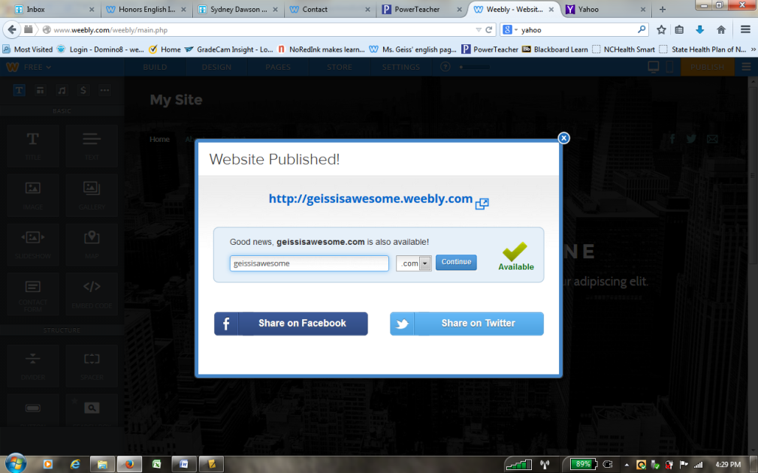
- Next, you need to get the link. To do this click on the upper right button (it has three horizontal lines) and select “Exit Editor.”
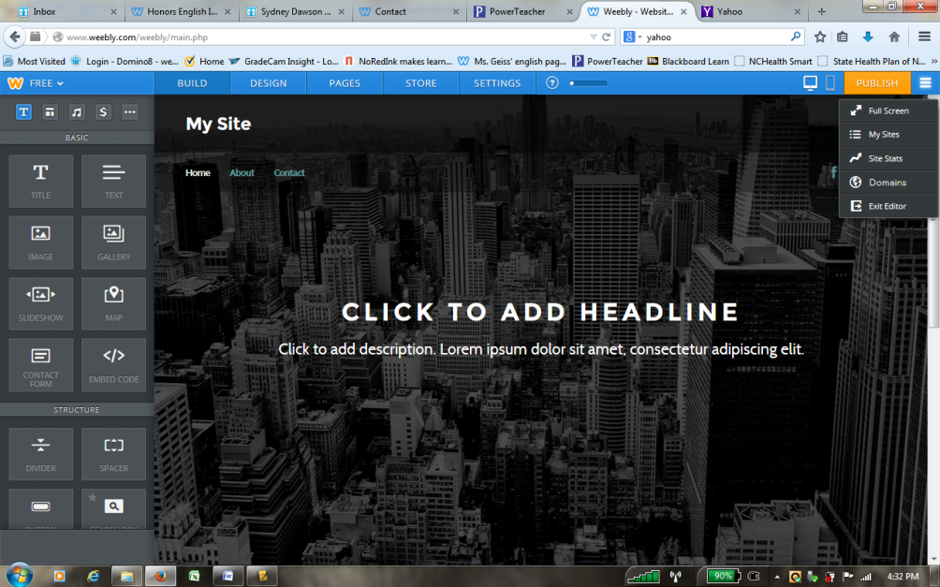
- The link that you want to copy and paste is located on the main screen. Please copy and paste this link into an email and send it to jivey@wcpss.net
