ADDING YOUR RESUME TO GOOGLE DRIVE
- Login to your SCHOOL GOOGLE DRIVE
- Open a new tab and login to Canva. Go to your resume.
- NAME YOUR DOCUMENT: Click where the arrow in pointing. Put in your name followed by Resume.
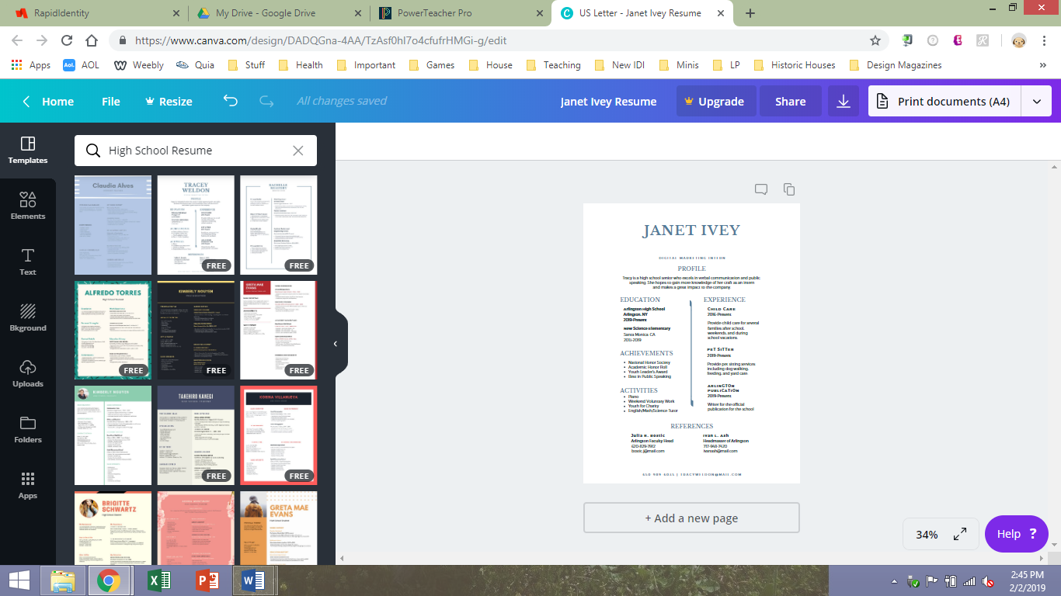
- DOWNLOAD: PDF Print High Quality
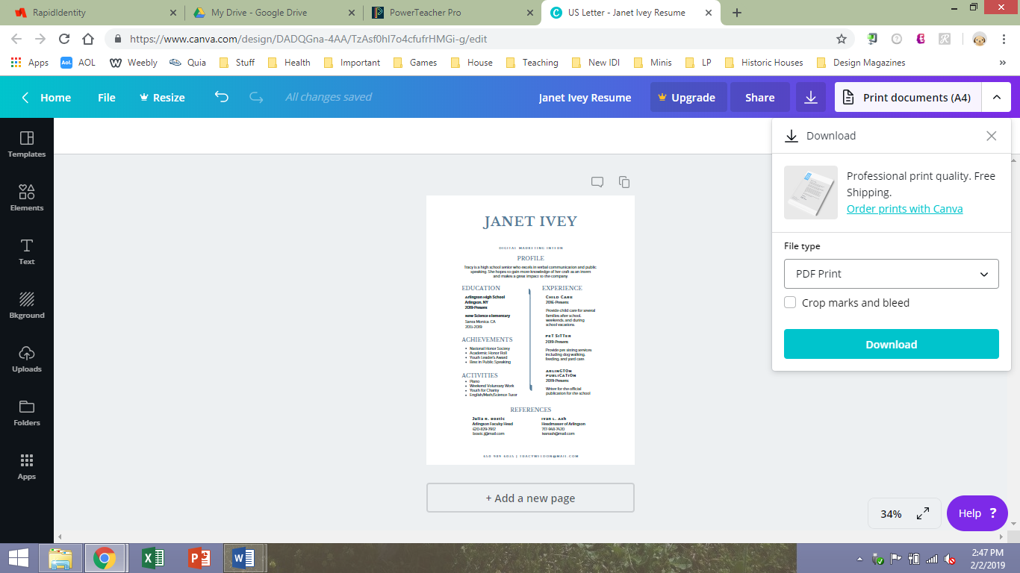

- OPEN YOUR DOCUMENT
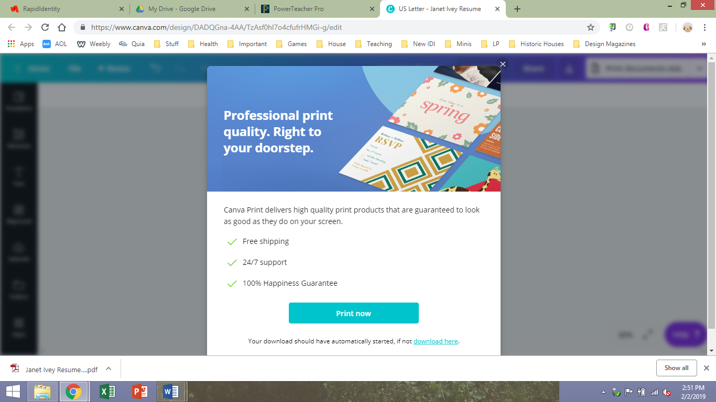
- CLICK ON THE “CHANGE” BUTTON
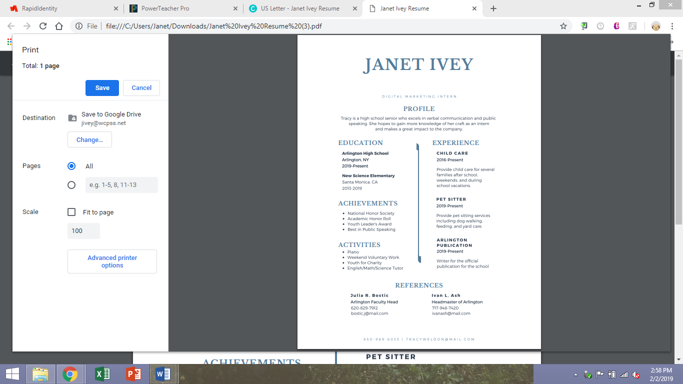

- MAKE SURE YOUR SCHOOL EMAIL IS SHOWING. CLICK “SAVE TO GOOGLE DRIVE”
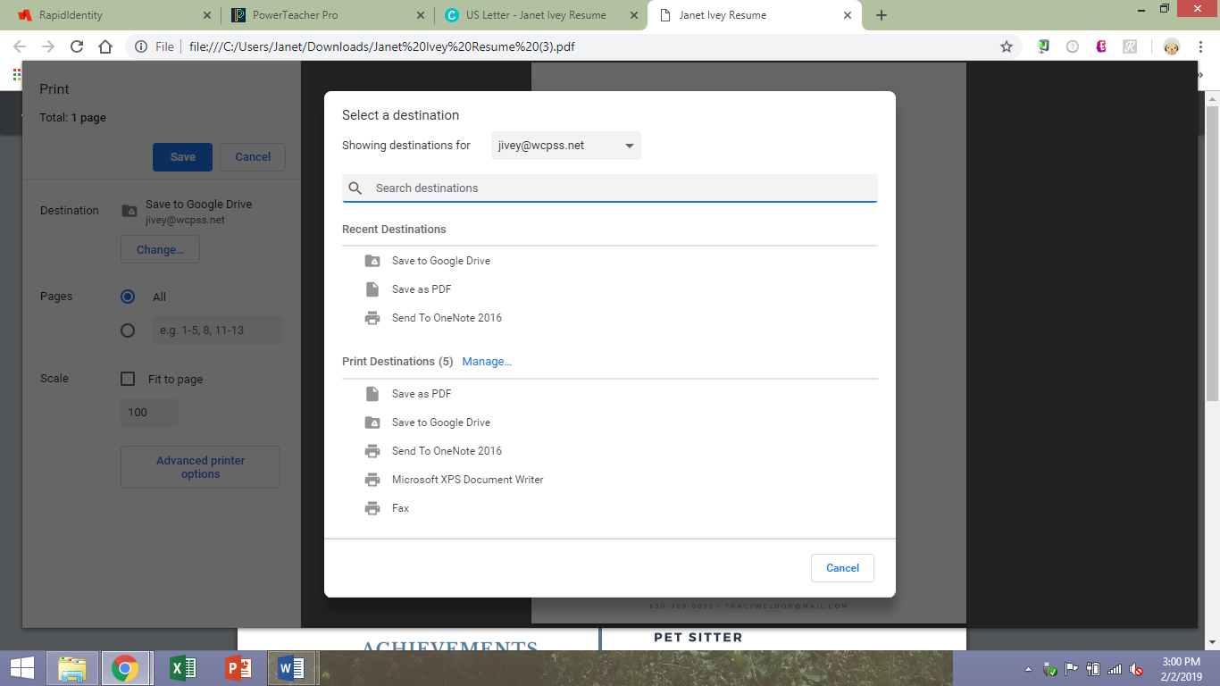
- CHECK AGAIN…THEN CLICK SAVE.
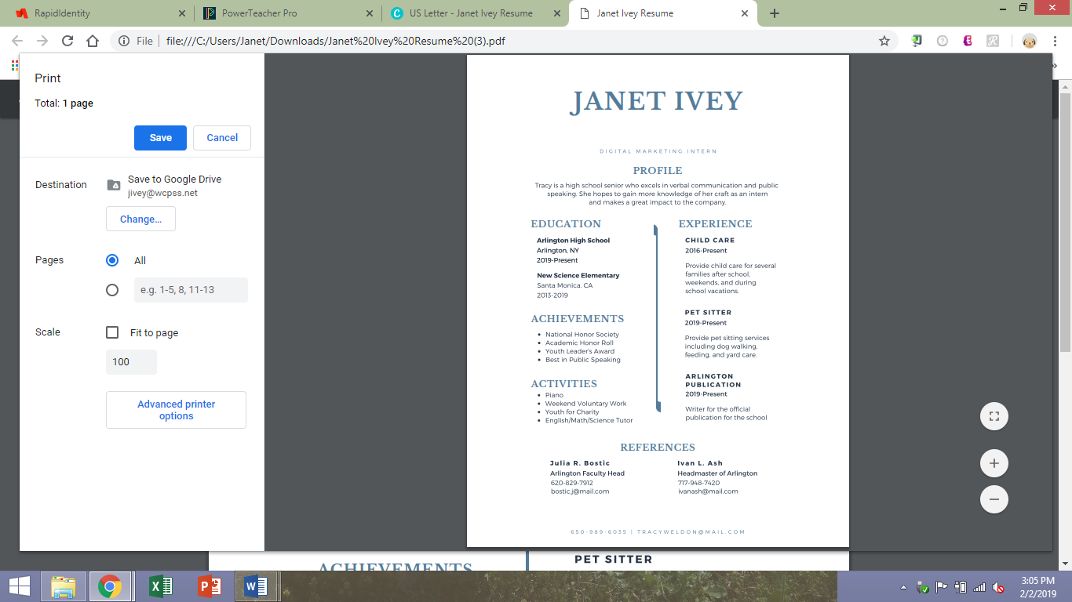

- GO TO YOUR SCHOOL GOOGLE DRIVE. SEARCH FOR YOUR RESUME.
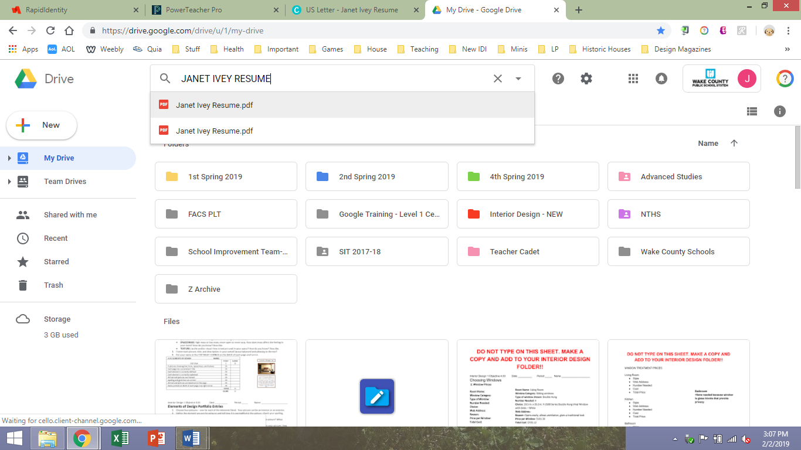

- CLICK ON THE 3 DOTS AND CHOOSE “MOVE TO” AND THEN YOUR IDII FOLDER.
