Interior Design II Objective 6.05-6.06 Date _______ Period _____ Name __________________

Creating an Electrical Plan

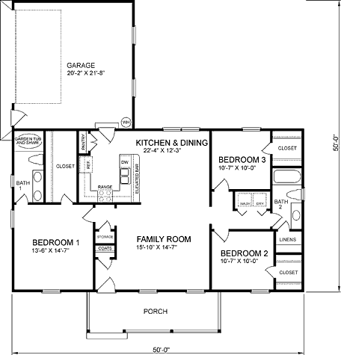Examine the house plan and decide where the electrical outlets, lighting, and switches need to be placed. Use an overlay and draw the symbols for your plan. (It helps to use dry erase markers first and then use a permanent marker once your plan is complete.)