Interior Design II Objective 6.02 Date __________ Period _____ Name __________________
Identifying Floor Plan Symbols
Instructions: Label all floor plan symbols using the schedule below. Then use an overlay and add the switches, structural lighting, electrical outlets, and cable TV outlets.

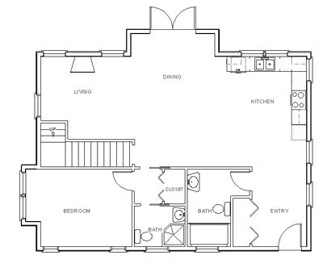

A | Exterior Door |  | I | Water Closet |  | Q | Dishwasher
B | Interior Door |  | J | Tub |  | R | Lower Cabinets
C | Bi-fold Door |  | K | Shower |  | S | Upper Cabinets
D | French Doors |  | L | Sink
E | Pocket Door |  | M | Double Sink
F | Fixed Windows |  | N | Range
G | Double-hung Windows |  | O | Refrigerator
H | Skylight |  | P | Stairs

